**EXPERIMENT 4**

**Title:** Designing animation using GIMP

**Objective:** To design an image with GIF format using GIMP.

**Theory:**

Graphics Interchange Format (often shortened to GIF) is a [file format](https://simple.wikipedia.org/wiki/File_format) for [images](https://simple.wikipedia.org/wiki/Images). It is a [raster graphics](https://simple.wikipedia.org/wiki/Raster_graphics) format; that is the image has a fixed size. The format supports up to 8 bits per pixel, or 256 colours. It also supports animations. Each frame of an animation has its own set of 256 colours. GIF is not used to show [photographs](https://simple.wikipedia.org/wiki/Photograph) very much, because having only 256 colours is limiting for such a task.

**Procedure:**

**Step 1:** Open GIMP on your Desktop/Laptop.

**Step 2:** In GIMP open the File menu and select Open. Alternatively, you can simultaneously press the Ctrl + O keys on your keyboard, for the same effect.

**Step 3:** This action launches the Open Image dialog. Browse to the folder where you stored your pictures. Then, select the first image that you want to use for the animated GIF.

**Step 4:** Next, you have to add all the other pictures that are going to be a part of your animated GIF file. To do that, open the File menu and click or tap on Open as Layers.

**Step 5:** Browse to the folder where you stored the pictures and open the second picture you want to use for the animated GIF file.

**NOTE:** If you have more pictures to add to the GIF file, repeat the last step: open the File menu, click or tap Open as Layers and select the next picture in your sequence.

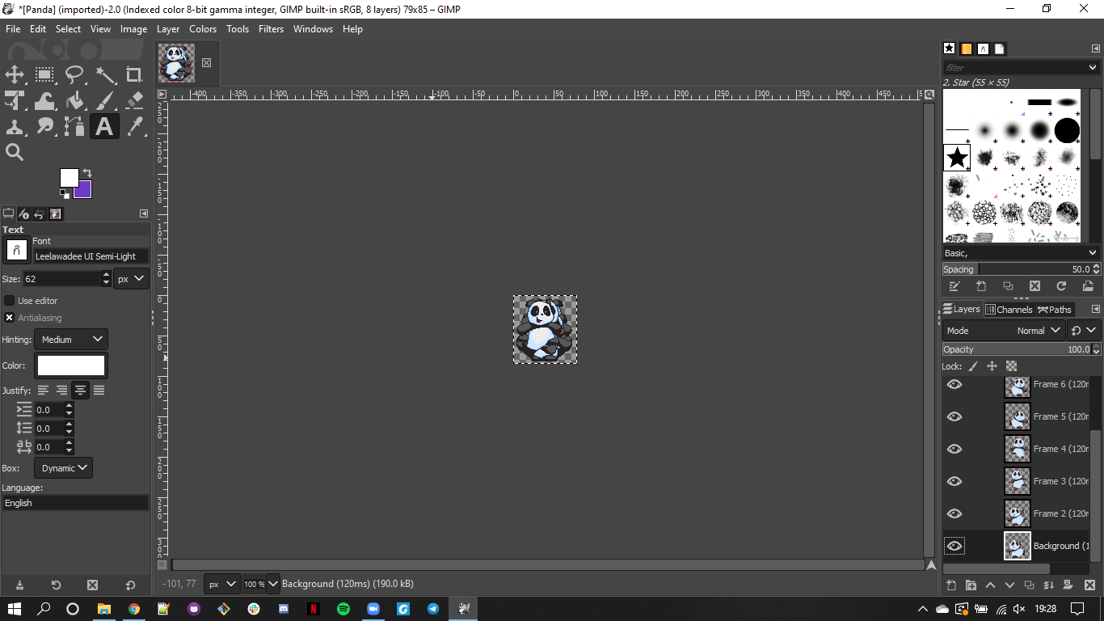

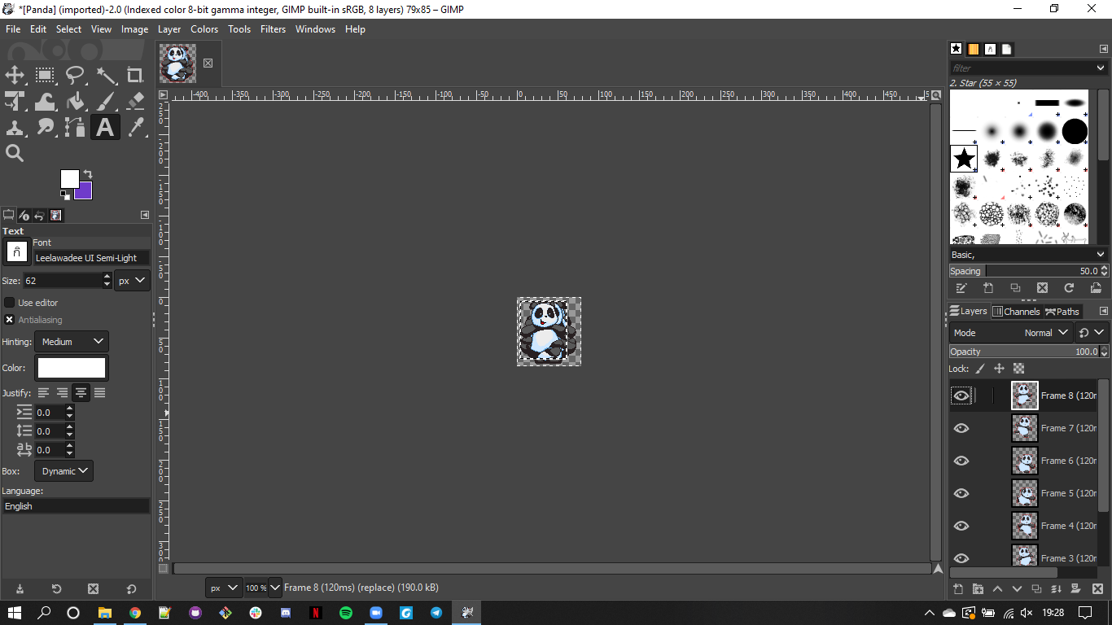

**Step 6:** When all the pictures are added, to get a preview of how your animated GIF file is going to look, open the Filters menu, go to Animation, and click or tap Playback.

**Step 7:** In the newly opened window, click or tap Play to preview your animated GIF file.

**Step 8:** To end the preview, close the Animation Playback window.

To finish creating your animated GIF file, save it. Open the File menu again, and click or tap Export As

**Step 9:** In the Export Image window, select the location where you want to save your GIF file, type a name for it and (very important) make sure you specify the GIF extension at its end. Then, click or tap Export.

**Step 10:** GIMP now opens a new dialog, called Export Image as GIF. The only essential thing to do here is to make sure you check the option called As animation. Another useful thing to set here is the delay used between the frames of your animation. When you have chosen all the settings that you want, click or tap Export.

**Conclusion:** Hence, the animation has been created.